**Exercise 5: Introduction to HTML/CSS**

**1. How are inline and block elements different from each other?**

● **Block-level elements** always start at new line and takes up the full width

available.

e.g. <div> , <p>, <pre>, <form> etc.

● **Inline element** does not start on a new line and only takes up as much width

as necessary.

e.g. <span>, <button>, <i>, <input>, etc.

**2. Explain the difference between visibility:hidden and display:none.**

● **display:none** means that the tag in question will not appear on the page at all

(although you can still interact with it through the dom). There will be no

space allocated for it between the other tags.

● **visibility:hidden** means that unlike display:none, the tag is not visible, but

space is allocated for it on the page. The tag is rendered, it just isn't seen on

the page.

**3. Explain the clear and float properties.**

● The **float property** is used for positioning and formatting content e.g. let an

image float left to the text in a container. The float property can have one of

the following values:

1. left - The element floats to the left of its container

2. right- The element floats to the right of its container

3. none - The element does not float (will be displayed just where it

occurs in the text). This is default

4. inherit - The element inherits the float value of its parent

● The **clear property** specifies what elements can float beside the cleared

element and on which side. The clear property can have one of the following

values:

1. none - Allows floating elements on both sides. This is default

2. left - No floating elements allowed on the left side

3. right- No floating elements allowed on the right side

4. both - No floating elements allowed on either the left or the right side

5. inherit - The element inherits the clear value of its parent

**4. Explain difference between absolute, relative,fixed and static.**

**● Static** : This is the default value. All elements are in order as they appear in

the document.

● **Relative** : the element is positioned relative to its normal position

● **Absolute** : The element is positioned absolutely to it’s first positioned

parent. It allows us to place our element precisely where we want it. If, there

is no positioned parent element, it will be positioned related directly to the

HTML element.

● **Fixed** : The element is positioned related to the browser

**5. Write the HTML code to create a table in which there are 4 columns(**

**ID , Employee Name, Designation, Department) and at least 6 rows.**

**Also do some styling to it.**

table {

display: table;

border-collapse: separate;

border-spacing: 2px;

border-color: gray;

}

<table>

<th>

<tr>ID</tr>

<tr>Employee name</tr>

<tr>designation</tr>

<tr>Department</tr>

</th>

<tr>

<td>02</td>

<td>vansh</td>

<td>trainee</td>

<td>bigdata</td>

</tr>

<tr>

<td>03</td>

<td>vartika</td>

<td>trainee</td>

<td>bigdata</td>

</tr><tr>

<td>01</td>

<td>yash</td>

<td>trainee</td>

<td>bigdata</td>

</tr><tr>

<td>01</td>

<td>vidit</td>

<td>trainee</td>

<td>bigdata</td>

</tr><tr>

<td>01</td>

<td>shaurya</td>

<td>trainee</td>

<td>bigdata</td>

</tr><tr>

<td>01</td>

<td>sachin</td>

<td>trainee</td>

<td>bigdata</td>

</tr>

</table>

**6. Why do we use meta tags?**

● The <meta> tag provides metadata about the HTML document. Metadata

will not be displayed on the page, but will be machine parsable.

● <meta> tag is typically used to specify page description, keywords, author of

the document, last modified and other meta data.

● The metadata can be used by the browsers, like how to display content or

reload page.

● E.g.

<head>

<meta charset=“UTF-8”>

<meta name=“keywords” content=“HTML, CSS, XML, JavaScript”>

</head>

**7. Explain box model.**

● All HTML elements can be considered as boxes. In CSS, this term is used

when talking about design and layout.

● It is essentially a box that wraps around every HTML element.

● It consists of : margins, borders, padding and the content.

**8. What are the different types of CSS Selectors?**

● CSS selectors are used to select the content you want to style. They are part

of CSS rule set.

● There are several types of selectors in CSS :

**○ CSS Element Selector:**

**○ CSS id Selector**

**○ CSS class Selector**

**○ CSS Universal Selector**

**CSS group selector**

**9.Define Doctype.**

The <!DOCTYPE> declaration must be the very first thing in your HTML

document, before the <html> tag.

The <!DOCTYPE> declaration is not an HTML tag; it is an instruction to

the web browser about what version of HTML the page is written in.

In HTML 4.01, the <!DOCTYPE> declaration refers to a DTD, because

HTML 4.01 was based on SGML. The DTD specifies the rules for the

markup language, so that the browsers render the content correctly.

HTML5 is not based on SGML, and therefore does not require a reference to

a DTD.

**10.Explain 5 HTML5 semantic tags.**

● **<section> (Section)**

A section is thematic grouping of content, typically with a heading.

● **<article> (Article)**

This element specifies independent, self-contained content. An article should

make sense on its own, and it should be possible to read it independently

from the rest of the web site.

● **<header> (Article)**

It should be used as a container for introductory content at the top generally.

● **<footer> (Footer)**

It should contain information about it’s containing element. A footer

typically contains the author of the document, copyright information, links

to terms of use, etc.

● **<nav> (Navigation)**

This tag defines a set of navigation links.

11.Create HTML for web-page.jpg (check resources, highest weightage for

answers)

Webpage.html

<!DOCTYPE html>

<html>

<head>

<link rel="stylesheet" type="text/css" href="mystyle.css">

</head>

<body>

<div class="to_the_new_heading">

<header class="blk">

<h1 class="txt">To The New </h1>

</header>

<nav>

<span> <a href=#LINK> HOME </a> </span>

<span> <a href=#LINK> ABOUT US </a> </span>

<span> <a href=#LINK> CONTACT </a> </span>

<span> <a href=#LINK> LOCATE US </a> </span>

</nav>

</div>

<div class="body_one">

<div class="content_body">

<div class="body_box">

<p class="box_content"> 960px x 360px </p>

</div>

<br>

<br>

<div class="light_grey_div">

<section class="light_grey_text">

You can't really succeed with a novel anyway; they're too big. It's like city planning. You can't plan a perfect city because there's too much going on that you can't take into account. You can, however, write a perfect sentence now and then. I have.

</section>

</div>

<h4 class="latest">Latest From The Galley </h4>

<hr size="1px">

<div class="row">

<div class="column">

<p class="image_text"> 215px x 315px </p>

</div>

<div class="column">

<p class="image_text"> 215px x 315px </p>

</div>

<div class="column">

<p class="image_text"> 215px x 315px </p>

</div>

<div class="column">

<p class="image_text"> 215px x 315px </p>

</div>

</div>

<br>

</div>

<footer class="footer_here">

<div>

<p class="footer_text">Copyright &copy; 2009-2017- All Rights Reserved - To The New </p> <p class="floater">Website Layout By To The New </p>

</div>

</footer>

<br>

<br>

</div>

</body>

</html>

mystyle.css

body{

background-color:#4f4949;

}

a{

color: #d9d9d9;

font-family: sans-serif;

font-weight:300;

padding: 5px;

}

nav{

background-color: #262626;

padding: 10px;

}

span{

padding: 10px;

}

.to_the_new_heading{

padding-left: 50px;

padding-right: 50px;

padding-bottom: 50px;

}

.content_body{

background-color: white;

border: 1px solid;

padding-left:70px;

padding-right:100px;

padding-top: 50px;

}

.body_one{

padding-left: 50px;

padding-right: 50px;

}

.body_box{

background-color: #262626;

width:960px;

height:360px;

padding-left: 10px;

padding-right: 30px;

padding-top: 1px;

padding-bottom: 50px;

}

.body_box_1{

background-color: #FFFFFF;

/*width:960px;

height:360px;

padding-left: 30px;

padding-right: 30px;

padding-top: 1px;

padding-bottom: 50px;*/

}

.box_content{

font-family: sans-serif;

color: white;

font-weight: bold;

font-size: 20px;

padding-left: 40%;

padding-right: 40%;

padding-top: 20%;

padding-bottom: 20%;

}

.box_content_1{

background-color: #262626;

font-family: sans-serif;

color: white;

width: 215px;

height: 315px;

font-weight: bold;

font-size: 20px;

}

.image_text{

color:white;

font-size: 14px;

font-family: sans-serif;

padding-left: 50px;

padding-right: 50px;

padding-top: 140px;

padding-bottom: 150px;

}

.footer_text{

float: left;

color: grey;

font-family: sans-serif;

font-size: 10px;

}

.floater{

color: grey;

font-family: sans-serif;

font-size: 10px;

float: right;

}

.row {

display: flex;

background-color: #FFFFFF;

font-family: sans-serif;

color: white;

}

.column {

border: 2px solid #cccccc;

background-color: #262626;

float: left;

flex: 25%;

padding: 10px;

height: 315px;

width: 215px;

padding-left: 5px;

padding-right: 5px;

padding-top: 10px;

padding-bottom: 10px;

margin: 10px;

}

.light_grey_div{

width: 960px;

}

.light_grey_text{

background-color: #cccccc;

padding-top: 5px;

}

.latest{

color: #d9d9d9;

font-family: sans-serif;

}

.blk{

background-color: #4f4949;

}

.txt{

color: white;

}

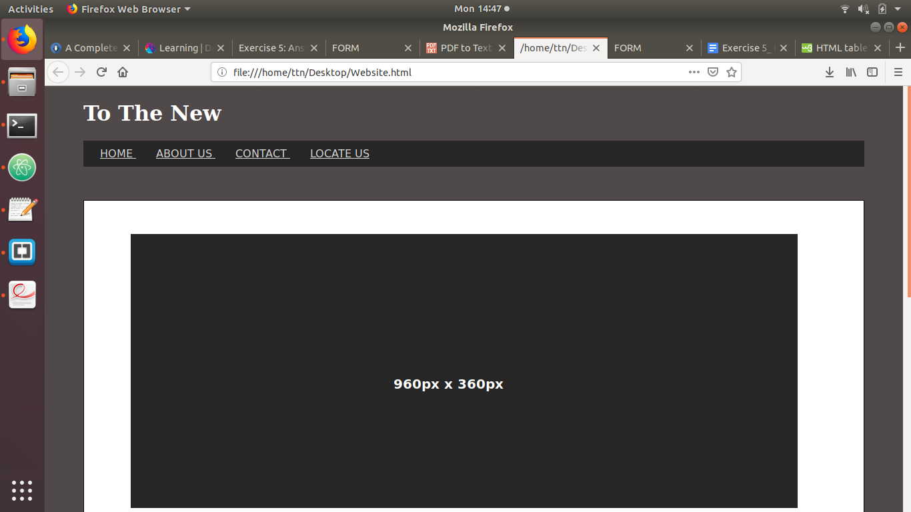

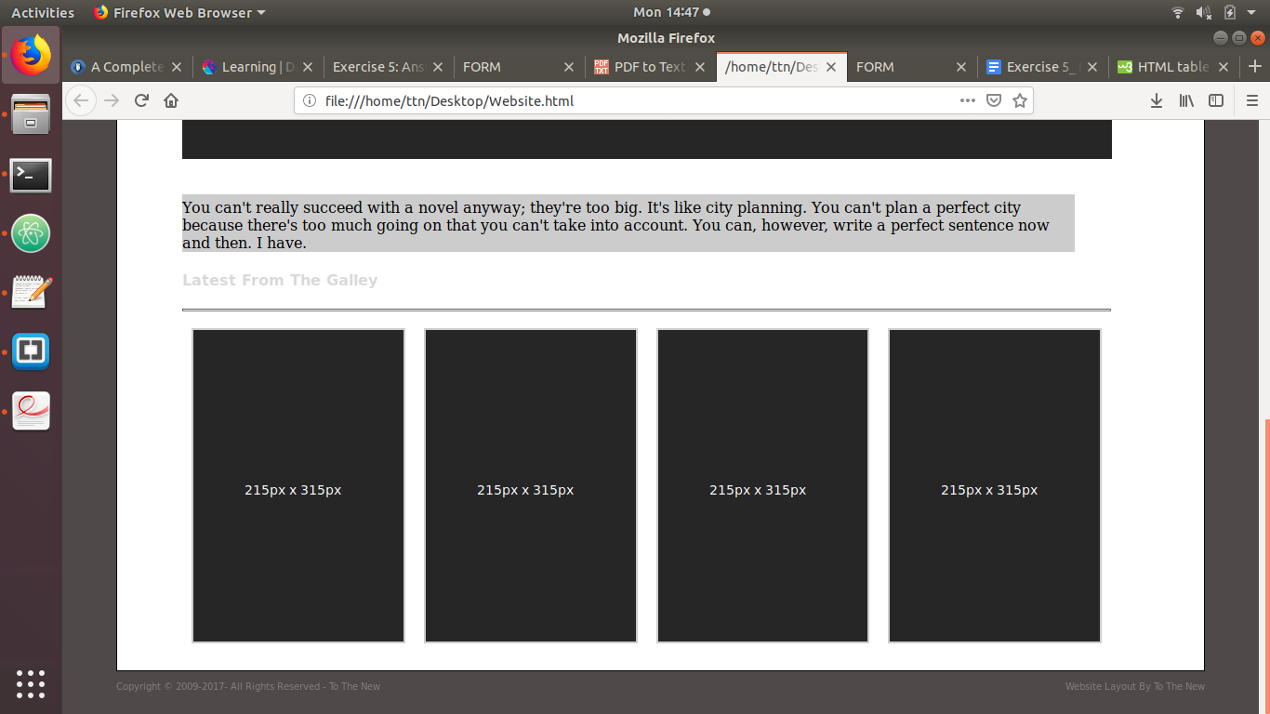

12.Create HTML for form.png (check resources, highest weightage for

answers)

Form.html

<!DOCTYPE html>

<html lang="en">

<head>

<meta charset="UTF-8">

<title>FORM</title>

<style>

.logo{

color: seagreen;

font-size: 30px;

padding-left: 100px;

padding-top: 5px;

float: left;

}

.links{

color: seagreen;

float: right;

padding-right: 100px;

padding-top: 10px;

}

ul#menu li{

display: inline-block;

padding: 0px;

}

links{

padding: 0px;

}

#home-line{

clear: both;

margin-left: 100px;

margin-right: 100px;

color: lightgrey;

}

.container{

position:absolute;

left: 50%;

transform: translateX(-50%);

border: 2px solid lightgrey ;

margin-bottom: 40px;

/*height: 600px;*/

width: 350px;

border-radius: 2%;

padding-top: 0px;

}

.form-head {

background: lightgrey;

height: 50px;

width: 350px;

}

input[type=text], select {

width: 300px;

padding-right: 20px;

padding-left: 20px;

margin: 8px 0;

display: inline-block;

border: 1px solid #ccc;

border-radius: 4px;

box-sizing: border-box;

}

.drop-down{

height: 30px;

color: white;

background:seagreen;

-webkit-appearance: none

}

.radio{

font-size: 11px;

padding-left: 0px;

}

.custom-file-upload{

width: 300px;

border: 2px solid lightgrey;

border-radius: 4px;

}

.custom-button{

margin-top: 15px;

float: right;

padding: 10px;

margin-right: 15px;

color: white;

background: seagreen;

border: none;

border-radius: 4px;

}

</style>

</head>

<body>

<div >

<div class="logo">

TO THE NEW

</div>

<div class="links">

<ul id="menu" >

<li><a href="#" style="text-decoration: none;color: seagreen;padding-right: 2px">Home</a></li>

<li><a href="#" style="text-decoration: none;color: seagreen;padding-left: 2px">Quick Help</a></li>

</ul>

</div>

</div>

<hr id="home-line">

<div class="container">

<div class="form-head">

<h3 style="margin-top: 0;padding-top: 12px;padding-left: 10px;color: #ffffff">Bug Report</h3>

</div>

<div class="form-body">

<form>

<p style="padding-left: 20px;font-size: 13px;margin-bottom: 0px">Title:<sup>*</sup></p>

<div style="padding-left: 20px;margin-top: 0px">

<input type="text" style="height: 30px;padding-top: 0px"/>

</div>

<p style="padding-left: 20px;font-size: 13px;margin-bottom: 0px">Description<sup>*</sup></p>

<div style="padding-left: 20px;padding-top: 5px;margin-top: 0px">

<textarea style="height: 70px;padding-top: 0px;width: 300px;border: 1px solid #ccc;border-radius: 4px"></textarea>

</div>

<p style="padding-left: 20px;font-size: 13px;margin-bottom: 0px">Operating System<sup>*</sup></p>

<div style="padding-left: 20px;padding-top: 5px;margin-top: 0px">

<select class = "drop-down">

<option class="drop-down">Windows XP</option>

<option class="drop-down">Windows 7</option>

<option class="drop-down">Windows 8</option>

<option class="drop-down">Windows 10</option>

</select>

</div>

<p style="padding-left: 20px;font-size: 13px;margin-bottom: 0px">Product<sup>*</sup></p>

<div style="padding-left: 20px;padding-top: 5px;margin-top: 0px">

<select class = "drop-down">

<option class="drop-down">Webapp</option>

<option class="drop-down">Android</option>

<option class="drop-down">ios</option>

</select>

</div>

<p style="padding-left: 20px;font-size: 13px;margin-bottom: 0px">Version<sup>*</sup></p>

<div style="padding-left: 20px;margin-top: 0px">

<input type="text" style="height: 30px;padding-top: 0px;width: 80px"/>

</div>

<p style="padding-left: 20px;font-size: 13px;margin-bottom: 0px">License:<sup>*</sup></p>

<div style="padding-left: 20px">

<input type="radio" name="Free" value="Free" style="padding-left: 20px" />

<label class="radio" >Free</label>

<input type="radio" name="Business" value="Business" style="padding-left: 60px;margin-left: 100px">

<label class="radio">Business</label>

</div>

<p style="padding-left: 20px;font-size: 13px;margin-bottom: 0px">Severity:<sup>*</sup></p>

<div style="padding-left: 20px;padding-top: 5px;margin-top: 0px">

<select class = "drop-down">

<option class="drop-down">low</option>

<option class="drop-down">moderate</option>

<option class="drop-down">High</option>

</select>

</div>

<p style="padding-left: 20px;font-size: 13px;margin-bottom: 0px">Severity:<sup>*</sup></p>

<div style="padding-left: 20px">

<input type="file" class="custom-file-upload"/>

</div>

<div class="form-head" style="margin-top: 10px">

<button class="custom-button">Submit</button>

</div>

</form>

</div>

</div>

</body>

</html>

